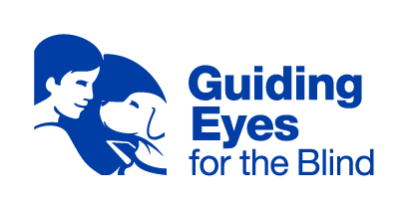
Headquarters and Training Center
611 Granite Springs Rd.
Yorktown Heights, NY 10598
914-245-4024 or Toll-Free 800-942-0149
Client Experience Team
clientexperience@guidingeyes.org
Applicant and Graduate Support: 888-987-2188

Dear Guiding Eyes for the Blind Graduate,

Congratulations! You have completed training with your new partner, and it is time to travel home and apply the skills you have learned to your daily routine. Keep in mind that no transition is without a learning curve. You and your dog may experience a few struggles along the way as you develop a bond. It is an emotional journey. Give extra praise as you and your dog navigate routes, target objects, practice obedience, and make strides in becoming a strong team. Be patient with one another whenever possible. If one of you gives up or becomes frustrated, the other can sense it. Remain diligent, confident, and prepared to problem-solve in a variety of situations. Remember that your Guiding Eyes community is behind you every step of the way; you can contact the Client Experience Team at 888-987-2188 or clientexperience@guidingeyes.org or contact Graduate Council members at gebgradcouncil@gmail.com for additional support.

It is my humblest and deepest honor to serve as the Community Outreach and Graduate Support Manager at Guiding Eyes. As a fellow graduate, I will stand with you through the challenges and rewards, joy, and grief, learning curves and milestones that define the incredible bonds we share with our dogs. It is my goal to offer guidance to our community whenever possible, whether that be sharing resources, providing updates on key legislation that could impact our teams, or offering individualized support. If you have any questions or concerns, please contact me at mcarney@guidingeyes.org or (845) 519-8419.

I wish you all the happiness and success as a new team.

Sincerely,

Melissa Carney

03/2022

