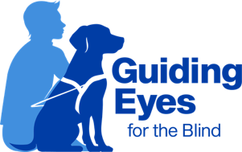
Chapter 37: Home Customization Day

During the last week of class, we dedicate a day to customized travel based on similar environments to when you return home. Each team will work one on one with an instructor. You may be working with one of the class instructors, placement manager, or a guest instructor. Due to the trip potentially taking several hours for each team, additional instructors join us for the day to help us provide one-on-one instruction. Make sure you pack plenty of treats and pick up bags. If you have been working with additional equipment to help with control such as a halti or a starmark collar, be sure to bring it with you.

If you currently use a subway system or do extensive city travel, we have the potential to visit NYC. Your instructor will give insight as to how you and your dog are progressing and if this would be a valuable experience for you and your dog. This trip will give you the chance to use the subway with your dog. Please note that this trip is not an opportunity for sightseeing, but rather an opportunity to receive firsthand experience of working in a very congested city environment.

If working in a city is not the right environment for you, you will have the opportunity to train in other local towns that provide similar travel to what you do at home. Some options include train or bus travel, small towns, sidewalk-less travel, college campus, or farm exposure. Regardless of the type of environment you chose to work in on this day, there will be a class lunch out at a restaurant on this day.

Updated July 2024

