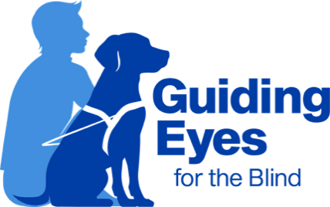
Headquarters and Training Center
611 Granite Springs Rd.
Yorktown Heights, NY 10598
914-245-4024 or Toll-Free 800-942-0149
Client Experience Team
clientexperience@guidingeyes.org
Applicant and Graduate Support: 888-987-2188

Guide to International Travel

International destinations pose exciting prospects for travel enthusiasts. Whether you want to snap a picture of you and your guide dog in front of the Eiffel Tower, roam the busy streets of London, or enjoy a watery affair in Venice, Guiding Eyes for the Blind would like to offer some guidance to prepare ahead of time. Traveling internationally with your guide dog requires significant advanced planning, as both entering another country and returning to the US require medical paperwork for your four-legged explorer.

Research your destination country’s entry requirements.
You can search for your destination country’s requirements by utilizing the Animal and Plant Health Inspection Service (APHIS) website. Please note that requirements for pets and service animals are often the same.
You may also ask a USDA accredited vet for guidance

Locate a USDA accredited veterinarian near you.
Use the USDA’s Veterinary Services Process Streamlining (VSPS) self-search tool. A USDA accredited vet will be able to assist you with the process and medical paperwork for traveling internationally with your guide. At the very least, you may need an International Health Certificate. The process for traveling internationally with your guide dog takes time and may have an associated cost. It is best to give yourself several months between when you book your trip and when you embark.

Research your destination country’s access laws for service animals.
Service animals are sometimes referred to as assistance dogs in other places. The Americans with Disabilities Act (ADA) and other federal laws do not apply outside of the United States. However, some countries may have similar protections.
For assistance, you may contact the country’s embassy. Alternatively, if you are working with a travel agency, they may be able to provide further information.

Research your specific airline’s requirements for flying with a service animal.
You must complete the Department of Transportation (DOT) Service Animal Air Transportation Form for all flights originating in and returning to the US, regardless of airline, as well as the Relief Attestation Form if your flights are more than 8 hours long. However, the submission process varies between airlines. Visit our airline travel resource guide for more information and detailed requirements.

Complete necessary paperwork for returning to the US.
Be mindful of additional requirements for reentering the United States. As of August 1, 2024, the CDC created new regulations to protect against dog Rabies. There are different regulations depending on the country you are traveling back from and whether it is considered a High- or low-risk country for Rabies. You can view a list of countries considered high-risk for dog Rabies here. If you are traveling from a low-risk country for Rabies, the only form you will need to complete is the CDC Dog Import Form. After you submit the form, a receipt will be sent to the email address provided. This receipt is valid for 6 months from the date of issuance. You will be asked to display it to your airline before boarding and U.S. Customs and Border Protection when the dog arrives in the United States. If you are traveling from a High-Risk country for Rabies, you will also need to obtain a Certification of U.S.-issued Rabies Vaccination form that must be completed by a USDA-accredited veterinarian.

Additional Resources
USDA Animal and Plant Health Inspection Service's Customer Service
Phone: 1-844-820-2234
Email: CustomerServiceCallCenter@usda.gov

For more information on CDC guidelines to enter the US, visit:
https://www.cdc.gov/importation/dogs/index.html
Or call the CDC at 800-232-4636.

