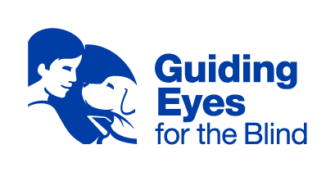
Headquarters and Training Center
611 Granite Springs Rd.
Yorktown Heights, NY 10598
914-245-4024 or Toll-Free 800-942-0149
Client Experience Team
clientexperience@guidingeyes.org
Applicant and Graduate Support: 888-987-2188

To Whom It May Concern:

The purpose of this letter is to inform you that one of your tenants has recently undergone intensive training at Guiding Eyes for the Blind, a member of the International Guide Dog Federation, to receive a qualified guide dog.

A guide dog is a very specific type of service animal that offers an individual who is blind or has low vision greater confidence and independence through daily travel. Each guide dog completes a rigorous training course over approximately a 2-year period in which they are taught obedience, house manners, socialization skills, and working commands. When in harness, a guide dog helps their handler navigate walking routes by avoiding obstacles, indicating street curbs/steps, and targeting specific locations, among other tasks.

Every guide dog team is protected against discrimination under federal law, the Americans with Disabilities Act (ADA). As defined by Title II and III of the ADA, a service animal is any dog that has been individually trained to do work or perform tasks for the benefit of an individual with a disability. Guide dog handlers are not legally required to provide any documentation, medical records, or any other paperwork proving that their guide dog is a service animal. Emotional Support Animals (ESAs), on the other hand, are not service animals by law and can be asked for documentation. While ESAs may assist with companionship and easing depression and/or anxiety, they do not have formal training to perform tasks that assist people with disabilities. They are pets that provide instinctual comfort. Service dogs, by law, are permitted to accompany their handlers into their private living quarters or public spaces.

The Fair Housing Act works in tandem with the Americans with Disabilities Act. Housing providers can only ask two questions: “Is the animal required because of a disability?” and “what work or task has the animal been trained to perform?” Under no circumstance can a service handler be asked for documentation, especially if their disability and job functions of the dog are apparent. In the case of a guide dog, both the disability of the handler and the duties of the service animal are clearly visible. Guide dogs wear unique harnesses. By law, the handler cannot be charged extra rent or be asked for a security deposit that pertains to the animal.

Guide dog handlers are fully responsible for the maintenance and behavior of their dogs. Their dog should always be clean and well-groomed. They will be quiet, calm, and collected while in public common areas. However, do keep in mind that, while extensively trained, service animals are not robots and cannot be expected to be perfect. As part of continued training, the handler must be given the opportunity to first work through mistakes and misjudgment before further action is taken.

If you have any further questions about service animals, you may learn more at ADA.gov or HUD.gov.

