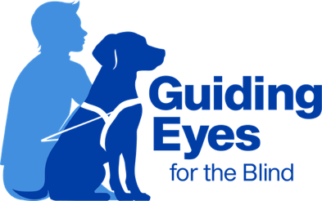
Headquarters and Training Center
611 Granite Springs Rd.
Yorktown Heights, NY 10598
914-245-4024 or Toll-Free 800-942-0149
Client Experience Team
clientexperience@guidingeyes.org
Applicant and Graduate Support: 888-987-2188

Guide to Lost Dog Prevention

As diligent as we must be as handlers, sometimes the unexpected occurs. A family member left a door cracked while bringing groceries into the house, or your guide pulled away from you to engage with a neighborhood dog friend down the street. Whatever the circumstance, losing your guide dog is a frightening, stressful, and disorienting experience. We would like to provide guidance to help proactively prevent these incidents and/or take the proper actions to report and locate a lost dog.

Preventative measures:

- Always keep a collar with tags on your dog. In addition to your standard Guiding Eyes and Rabies tags, include a customized tag with your name and phone number.
- Register your guide with your local town/city.
- Practice your dog’s obedience and recall
- If you cannot yell, consider whistle training your guide.
- Be aware of where your dog is at all times. While at home, you may consider placing a small bell on your dog’s collar so you can more easily detect their movements.
- If your guide is often overly excitable when greeting guests at the door, keep him/her on leash to minimize the chance of the dog slipping out the door.
- Remind guests and family members to securely close all doors to the home upon entering and exiting.
- Regularly check that the locks and latches on your doors or gates are functioning properly.
- Never leave your dog unattended in your yard, even if it is fenced in.
- If you are moving or performing household tasks that require doors to be open frequently or for long durations of time, place your dog in a crate, secure room, or on tie-down.
- Update your address with Guiding Eyes if you move.

Steps you should take:

- If you notice your dog is missing, first check all rooms in the home to make sure he/she is not trapped anywhere.
- Call your dog by name and sound as upbeat as possible. A dog on the run will be more attracted to enthusiasm than frustration.
- Use your dog’s favorite treats and/or shake a bowl full of kibble to entice them to return home.
- Notify friends, family, and neighbors and ask their help with a search of the surrounding area. Think of your dog’s favorite hangout spots, the locations of other dogs in the neighborhood, familiar routes, etc.
- Call local police, animal control, and shelters to make them aware and ask that they be on the lookout.
- Post on social media describing the last place you saw your dog, color, breed, gender, and any other identifiable features, such as special markings or collar. Make the post public and sharable to assist in spreading the word.
- Notify your vet hospital and other local animal hospitals. If a concerned individual brings your dog in, they will be able to scan his/her microchip.
- Call Guiding Eyes to notify us and seek additional guidance
- Please update Guiding Eyes staff when the dog is found.

